Base Configuration  
  
capabilities.setCapability(MobileCapabilityType.*PLATFORM_NAME*, "ANDROID");  
capabilities.setCapability(MobileCapabilityType.*PLATFORM_VERSION*, "8.0");  
//capabilities.setCapability(MobileCapabilityType.DEVICE_NAME, "Android Emulator");  
capabilities.setCapability(MobileCapabilityType.*DEVICE_NAME*, "emulator-5554");  
capabilities.setCapability(MobileCapabilityType.*AUTOMATION_NAME*, "UiAutomator2");  
  
capabilities.setCapability(MobileCapabilityType.*APP*, appPath);  
capabilities.setCapability(MobileCapabilityType.*NEW_COMMAND_TIMEOUT*, 2000);  
capabilities.setCapability("appPackage", "com.msearcher.taptapsee.android");  
capabilities.setCapability("appActivity", "com.msearcher.taptapsee.activity.SplashActivity");  
capabilities.setCapability("autoGrantPermissions", true);

|  |  |  |  |  |
| --- | --- | --- | --- | --- |
| Id |  | Platform Version | Duration | Notes |
| 1 | 8 Foldable API 29 | 10.0 | 44s | Need to close a camera related button at first time run |
| 2 | Pixel 3 XL API 29 (22-29) | 10.0 | 44s | Need to close a camera related button at first time run |
| 3 | Pixel 2 API 29 (24-29) | 10.0 | 33s | Passed after manual walk through finished. Stuck at android:id/button1 line 66 |
| 4 | Nexus S API 22 (22-29) | 5.1 |  | * 5.1.1 will not work. app bug.  * not compatible with latest appium * 'By.id: android:id/button1' does not exist in DOM anymore. * {Using=xpath, value=//android.widget.TextView[@text='Automation']} Not Found * Stops after 1st page recognition. |
| 5B | Nexus 6 API 27 (22-29) | 8.1 |  | 2nd button click will not work |
| 5 | Nexus 6 API 27 (22-29) | 8.1 x86 |  | Image select 1 not found andoird.view.viewgroudp[@index=1] did not find. //android.view.ViewGroup[@content-desc="Photo taken on Jan 9, 2020 11:11:48 AM."] required |
| 6 | Galaxy S10 Black API 29 | 10.0 x86_64 |  | App Error: no google play available |
| 7 | Pixel 3 API 29, skin | 10.0 x86_64 |  | App Error: no google play available |
| 8 | Pixel 3 API 24 | 7.0 arm64-v8a |  | 10 times slower not acceptable |

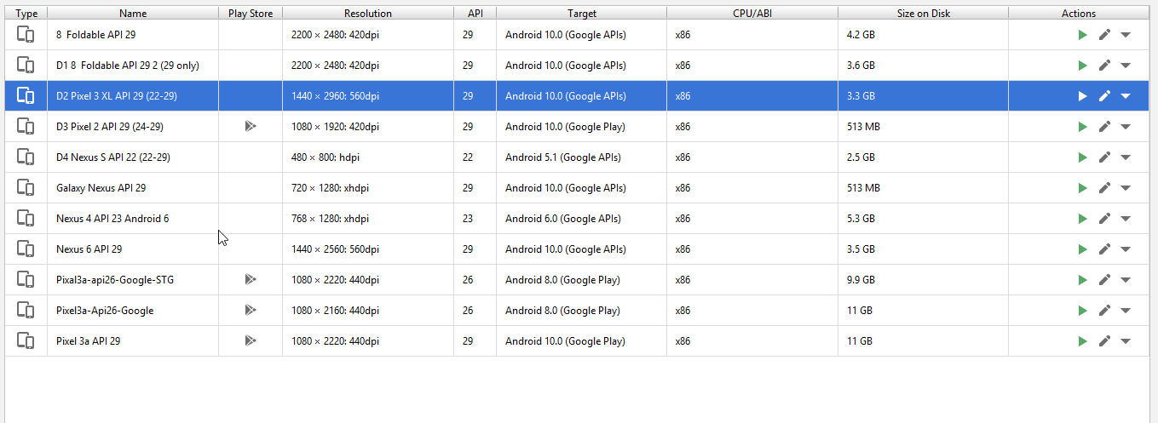  
  
D3-1  
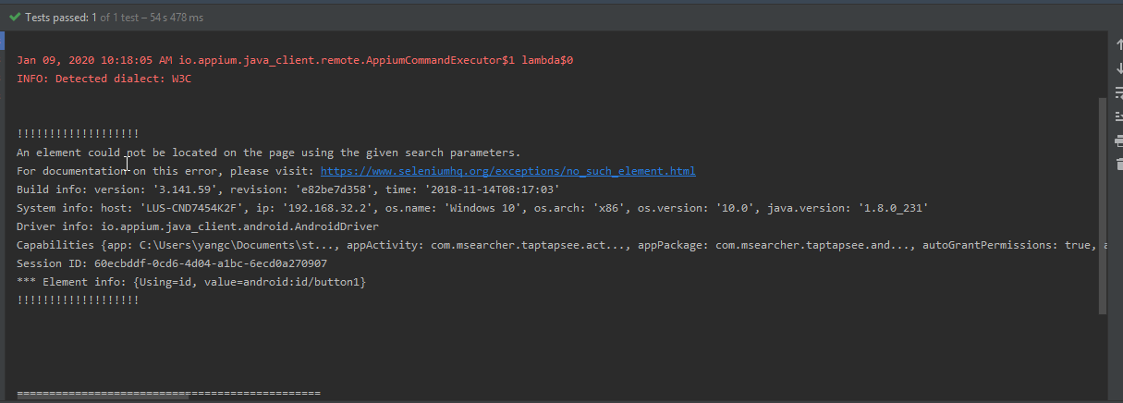  
D3-2 failed  
  
D4-2 failed  
{Using=xpath, value=//android.widget.TextView[@text='Automation']} Not Found